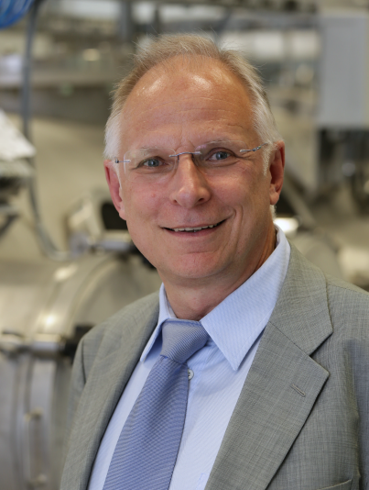
Professor Dr. Horst-Christian Langowski
born 03.02.1954
Current positions: Senior scientist at Fraunhofer IVV (assigned to the institute directorate) and lecturer for packaging technology at the TU Munich

Professional background:
1973 – 1980 Physics studies at the University of Hannover
1981 – 1991 Industrial activity in the field of optical data carriers (CD, CD-ROM, CD-R) at a company of the Philips Group
1985 – 1989 At the same time: Doctorate at the University of Hannover as Dr. rer. nat..
Since 1991 Scientist at the Fraunhofer Institute for Process Engineering and Packaging (Fraunhofer IVV), Freising, Germany
1992 Head of department at the Fraunhofer IVV, Freising
2003 - 2020 Director of the Chair of Food Packaging Technology at the Technical University of Munich, Weihenstephan Campus
2004 - 2007 Acting Director of the Fraunhofer IVV, Freising
2006 - 2019 Dean of Studies for Brewing and Food Technology at the TU Munich, Weihenstephan Campus
2007 - 2020 Institute Director of the Fraunhofer IVV, Freising
2017 - 2020 Chairman of the Fraunhofer Group for Life Sciences (VLS) and member of the Presidential Board of the Fraunhofer-Gesellschaft .

Other functions:
- Board member of the Center for Food and Packaging Technology e. V., Kempten
- Chairman of the Association of the Weihenstephan Dairy, Bio and Food Technologists e.V.
- Member of the Editorial Board of the journal Food Packaging and Shelf Life (IF 8.749)

